Application Overview for Student Marking Application

This application lets the user select a database containing student information and marks to sort and do calculations such as minimum, maximum, average, etc. of grades. The user may select specific courses students are enrolled in and assessment types to sort and do those calculations. Using those calculations, the user may also create a histogram chart with the data they requested. Furthermore, the user can export all the calculated data into a Word document for a clear and concise report of the generated data. The purpose of this application is to simplify the workflow of the user to easily search specific courses with the students marks in that course to generate reports.

Instructions on using the application:
- Follow the instructions provided in the first active worksheet upon opening the workbook.
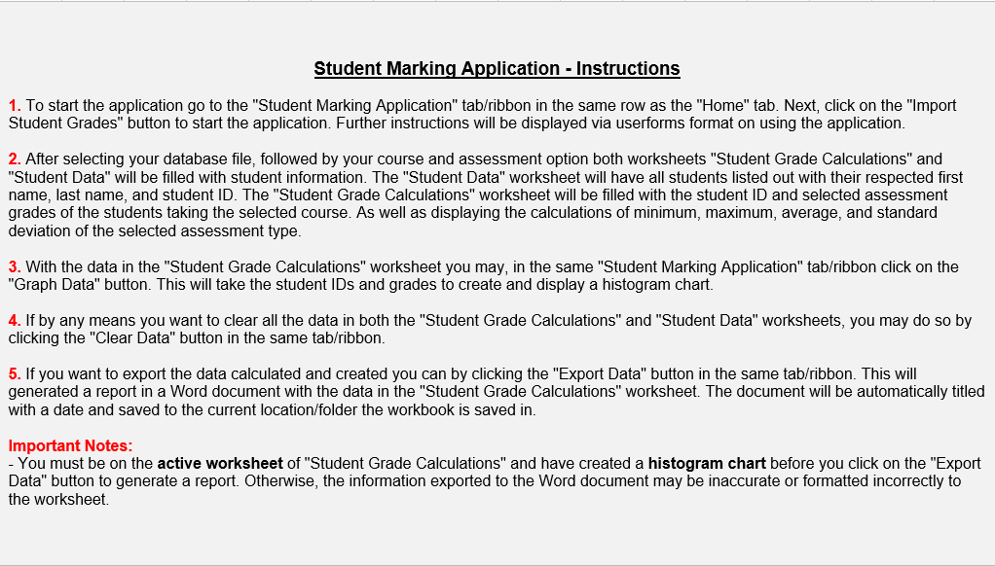
- The custom “Student Marking Application” ribbon/tab provides various buttons for different actions on calculations, creating charts, exporting data, and clearing worksheets.
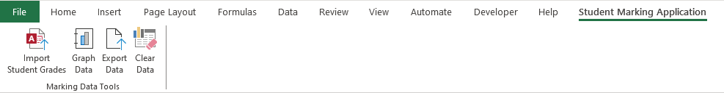

- This UserForm will show after clicking the “Import Student Grades” button which will allow you to browse for a database file to use for the application.
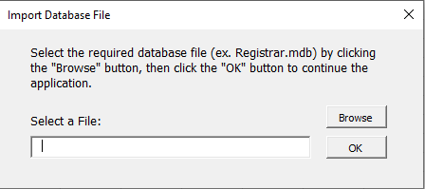
- After choosing an applicable database file for the application, this UserForm will pop up to prompt you to select your desired course and assessment type to use for mark calculations.
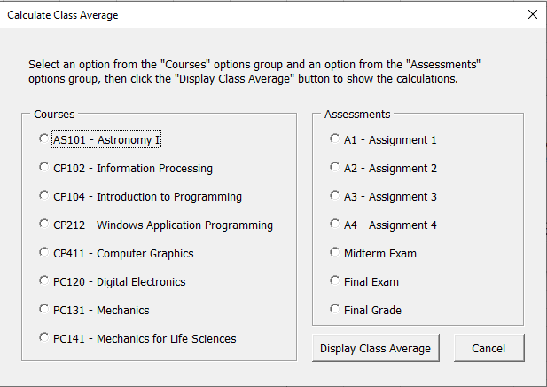
- Now you should see your selected course and assessment data and calculations displayed into the “Student Grade Calculations” worksheet. Additionally, you should see a list of all student information such as first name, last name, and student ID in the “Student Data” worksheet.
- After successfully importing the data and calculations you may graph the data into a histogram by clicking the “Graph Data” button in the same ribbon/tab. Your histogram chart may look like the image below.
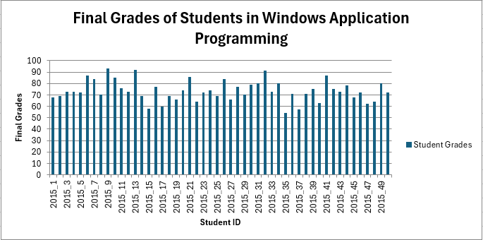
- You may optionally use the “Clear Data” button in the same ribbon/tab to clear all the data imported and calculated in the “Student Grade Calculations” and “Student Data” worksheets.
- If you would like to export the data, you can click on the “Export Data” button in the same ribbon/tab. Please take note of the “Important Notes” section of the instructions shown in the “Application Instructions” worksheet. Your generated Word document should look like the one below.
